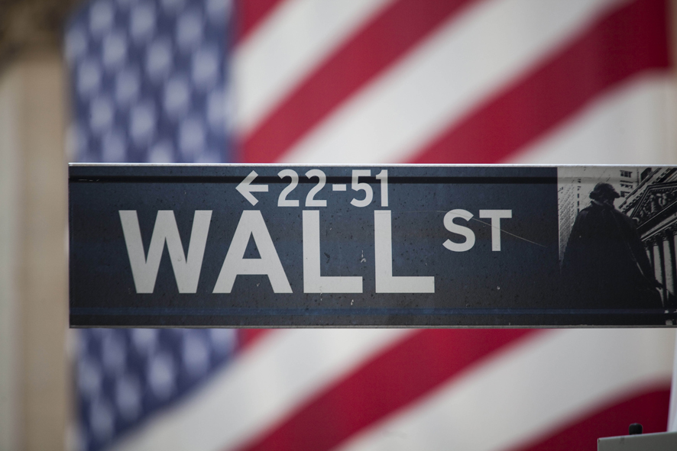
Ten-year-old Davie Langer says, “What’s going on is not cool.”
What does she mean by that?
“Some people have a lot of money,” she told a reporter from the New York Times. “(But) some people have to give a lot of their money and have little.”
That’s why Davie headed down to Zuccotti Park in New York City on Columbus Day to join a protest known as “Occupy Wall Street.”
For several weeks, protesters have been gathering around Wall Street – a street that’s considered the financial capital of the United States.
Why are they protesting?
They’re angry that so many people are unemployed right now.
And they say the rich are getting richer at the expense of the other 99 percent of the country.
(NOTE TO KIDS: Before we go any further, do NOT go to any protest without your parents – or another trusted grown-up who has your parents’ permission. Although the “Occupy Wall Street” protests have been mostly peaceful, there have been some violent confrontations between protesters and police officers. And some people have been arrested. This is NOT a place for kids to hang out on their own.)
Seven-year-old Caleb Horowitz also spent Columbus Day at Zuccotti Park – with his father and his 4-year-old brother, Toby.
Why did Caleb decide to go?

“Some people are very poor and have no homes and food,” he told Times reporter Alice Speri. “It’s true. I know a guy that is homeless.”
According to Speri, Caleb also carried a sign that said, “Being fair to all things. Eat less meat.”
He told her he wants “to protect animals.”
Nearby, 12-year-old Ellie Salen carried a sign that said, “Women’s Rights: Don’t Give an Inch.”
“I don’t want them taken away,” she told a reporter for Forbes Magazine, when asked why she was carrying the sign.
Sometimes, there seems to be as many messages as protesters.
Some are speaking out against global warming.
Others are demonstrating against the wars in Afghanistan and Iraq.
And still others are demanding affordable health care and better schools.
Sometimes, all those competing causes and messages seem to drown one another out.
It seems as if each protester is on his or her own mission.
And there’s no unified, organized voice.
But according to Central Park East II principal Naomi Smith, “This is what democracy looks like.”
Smith brought some of her students down to see the protest on Columbus Day.
“I thought it would be great for the children to see what’s happening here,” she told the Times.
“This is about democracy in action,” added Caterina Bartha, who reportedly came to the protest with her son Jacob.
“I’m showing my son there’s a process by which you can be heard – whether that’s at home or at school,” she told Forbes reporter Kiri Blakeley.
When asked about the protests, New York City Mayor Michael Bloomberg told reporters, “The bottom line is that people want to express themselves.”
“As long as they obey the laws, we allow them to,” he said, according to the Associated Press.
According to Blakeley, the Salens were visting from Pennsylvania.
And they only planned to stay one day, while the kids were off from school.
But during that day, they got a real-life lesson
“This is what we do in America,” said Ellie’s mom, Mary Salen. “We don’t stand back and be a victim.”

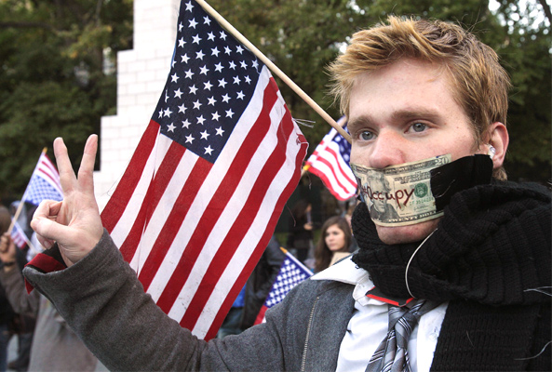
Many New York City protesters demonstrate near City Hall during the day and sleep in tents in nearby Zuccotti Park at night. (Frank Franklin II / AP Images)

What Is Occupy Wall Street?

A protest that started in New York City is spreading around the world. Who are the protesters and what do they want?
By Natalie Smith | November 2 , 2011
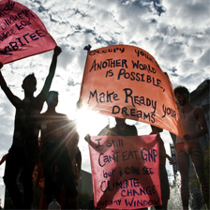
The Occupy protests have spread to more than 100 American cities.
(Alex Fradkin / Redux)

It started small, with about 1,000 protesters. The group gathered on September 17 near Wall Street in New York City. That’s the area where many of the biggest U.S. banks and financial companies have their headquarters. Now, almost seven weeks later, the protest, known as Occupy Wall Street, is a worldwide movement. The Occupy protests have spread to more than 1,500 cities around the world, including more than 100 U.S. cities.
Exactly what are people protesting? Around the globe, protesters have expressed different concerns, but most of their complaints have a common thread: the tough financial times and who is to blame for them. One of the biggest issues is the growing gap between the rich and the poor. The richest 1 percent of Americans earn nearly 25 percent of all U.S. income, according to a recent study. The Occupy protesters argue that large companies like those on Wall Street are making too much money while millions of Americans are struggling just to put food on the table. The protesters say they want average Americans to have more job opportunities and share in companies’ prosperity. They want their voices to be heard.
“The hope . . . is to show that through nonviolent protest, we can change this country,” says Alec Courtney. The 21-year-old from Brooklyn, New York, is out of work. “People can change. The government can change,” he adds.
The New York protesters come from all walks of life—from teens to retired workers. Many of them are college students or recent graduates without jobs. Others are workers who simply feel as if they will never get ahead. Their frustrations are shared by demonstrators throughout the country—and in other countries too.
But not everyone supports the movement. Many people have criticized the movement, saying the message of Occupy Wall Street isn’t clear. They also point out that the protesters have failed to offer solutions to the problems or to make specific demands.
The criticism hasn’t stopped the movement, though. The protesters say they’re here to stay.
“[The point is] to get the word out, start a movement,” says 18-year-old Spirit Fox, a high school student from New York. “I think this is the beginning.”

“We are the 99%!”

Occupy Wall Street
• On September 17, 2011, several hundred people gathered in the business district of New York City, the largest city in the United States and its financial capital. They came to protest against the increasing inequality of income and wealth in the country and against all the unemployment, poverty, and homelessness that has followed the economic crisis of 2008. They wanted to protest in the financial district, the “Wall Street” area, because that is the headquarters of the banking and investment industry which they think caused the problems.
• For a few hours they listened to speeches, talked in small groups, and marched through the streets. When night came, many of them went home but a few put up tents in Zuccotti Park, the most convenient place to camp in that part of the city. That was the start of the “Occupy Wall Street” movement. (“Wall Street” is actually the name of one of streets in the district but for a long time it has also been used to refer, in a general way, to American financial power.)
• This kind of protest quickly became very popular; within a month there were similar occupations in many other cities around the world. And the protesters showed themselves to be persistent; more than 200 of them remained in the park until they were forcibly evicted by the police on November 15, and even after that happened, they said intended to continue the occupation.
• There has been a lot of debate, both within the Occupy movement and outside it, about what its goals are — or should be. And it has often been criticized by people who say that it doesn’t really have any clear demands or definite ideas about how society should be changed. But everyone involved does seem to agree on one thing — that too much of the world’s wealth is in the hands of a small number of people. The protesters in the US have emphasized this fact by quoting statistics like this one: 40% of their country’s wealth is held by 1% of the population and, as a way of driving home their point, they have adopted the slogan, “We are the 99%!”

